85.2

#include <stdio.h>

#include <math.h>

int main()

{

int x1,y1,x2,y2;

float distance;

printf("Please input the first coordinates:\n");

scanf("%d,%d",&x1,&y1);

printf("Please input the second coordinates:\n");

scanf("%d,%d",&x2,&y2);

distance=sqrt((x1-x2)\*(x1-x2)+(y1-y2)\*(y1-y2));

printf("The distance is %f",distance);

return 0;

}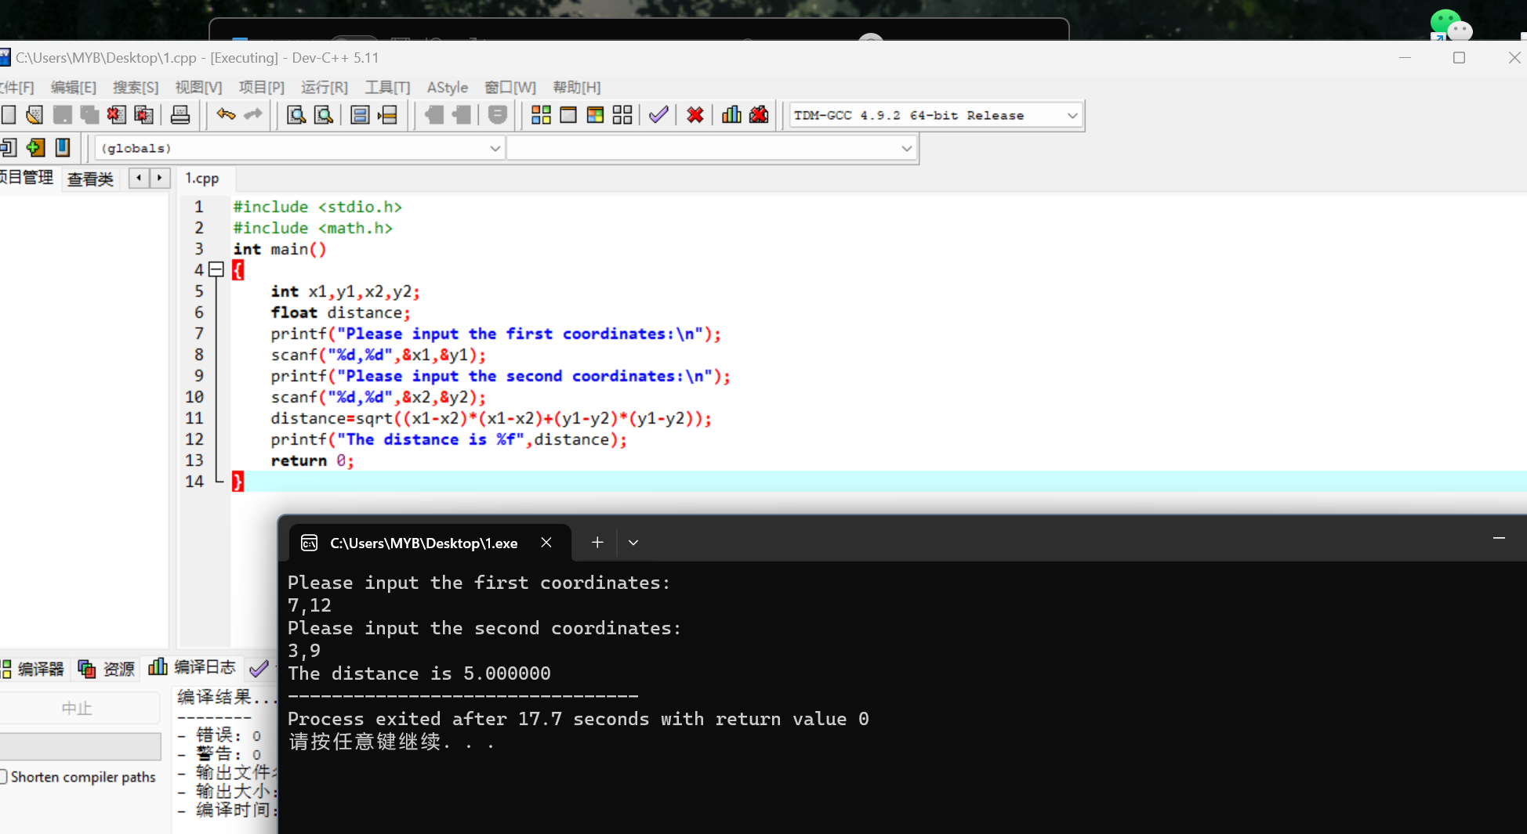

85.3

#include <stdio.h>

#include <math.h>

int main()

{

int a,b,c;

float area,s;

printf("Please input the sides abc of a triangle:");

scanf("%d,%d,%d",&a,&b,&c);

s=(a+b+c)/2.0;

area=sqrt(s\*(s-a)\*(s-b)\*(s-c));

printf("\nThe area of a triangle is %f",area);

return 0;

}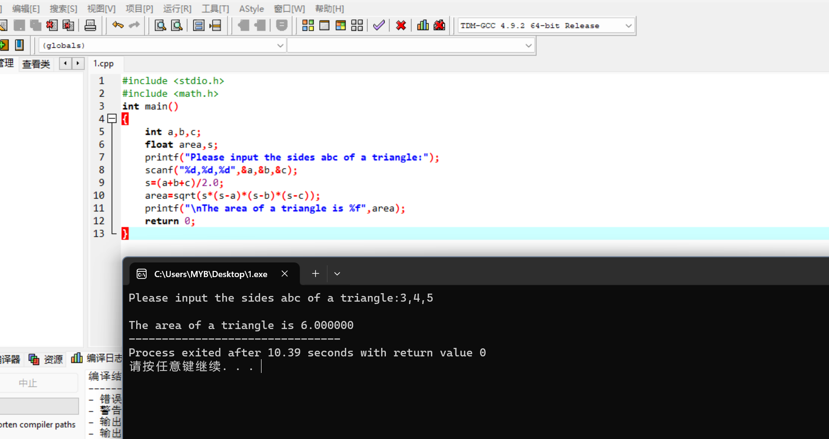

85.6

#include <stdio.h>

#include <math.h>

int main()

{

int deposit,year;

float rate,amount;

printf("Please input the deposit of money,the year you want to wait and the interest rate that bank give you:");

scanf("%d,%d,%f",&deposit,&year,&rate);

amount=deposit\*pow(1+rate,year);

printf("The final amount is %f",amount);

return 0;

}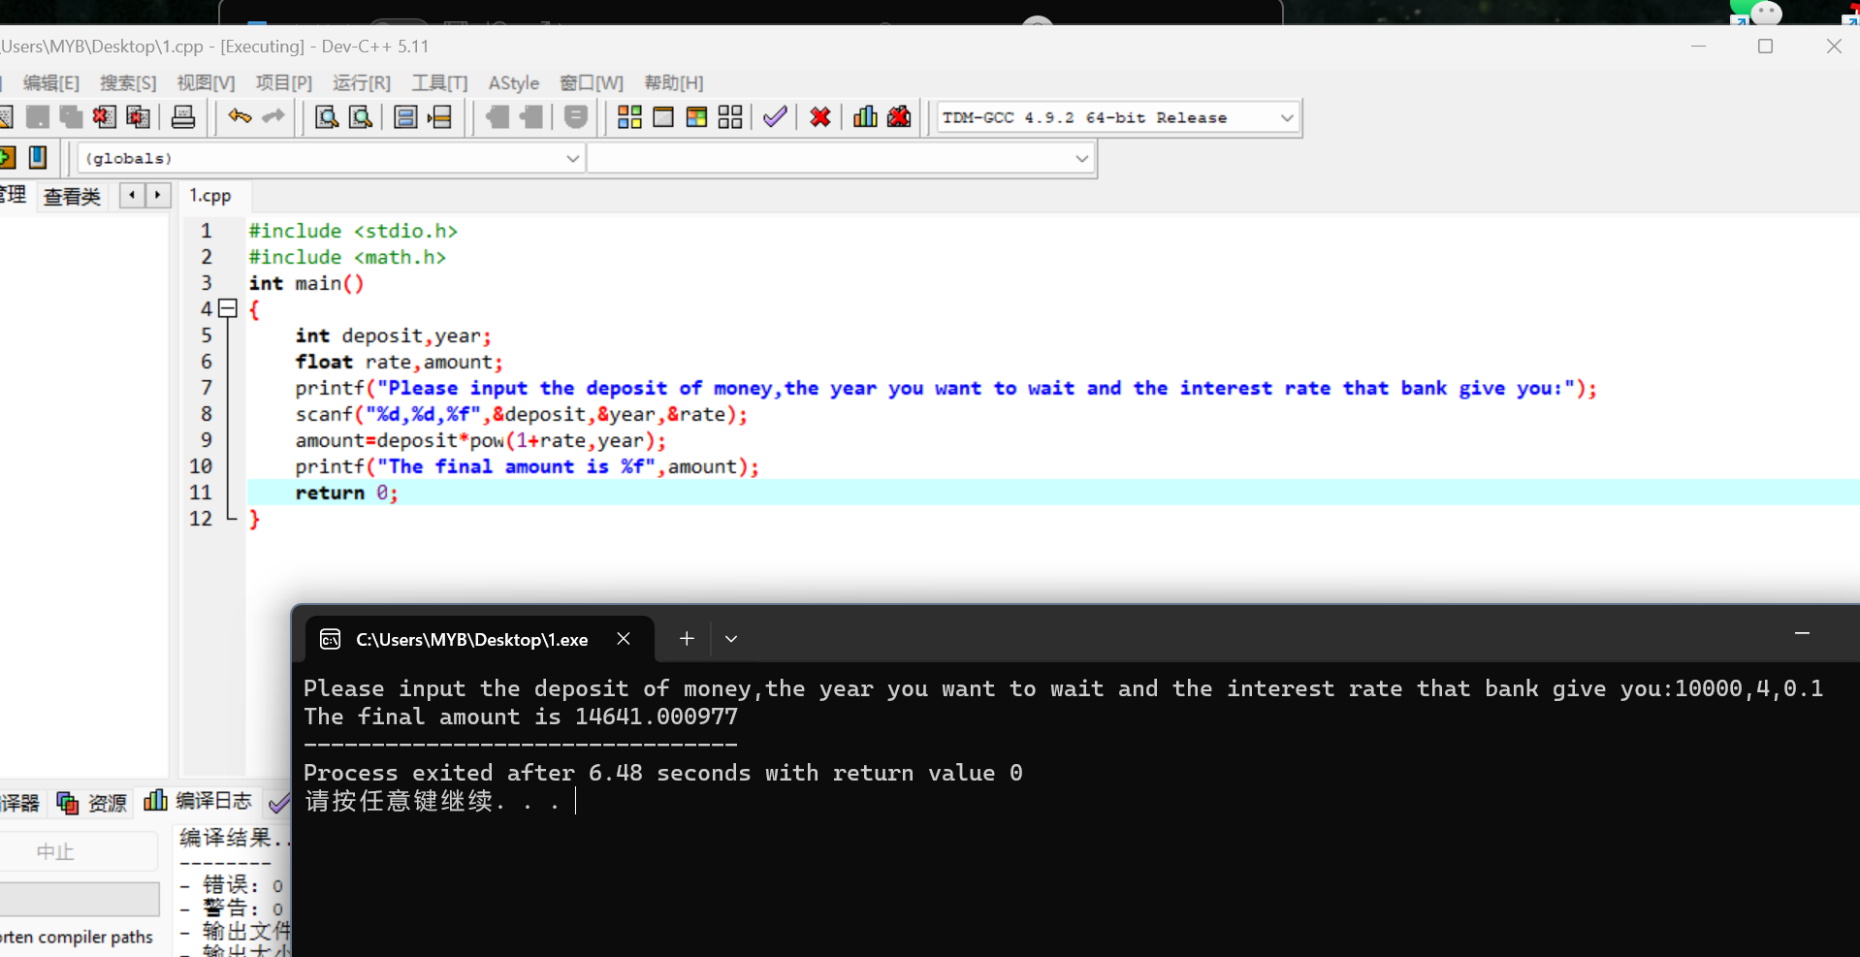

92.1.a

#include <stdio.h>

#include <math.h>

int main()

{

float radius,circumference,PI=3.1416;

printf("Enter the radius of a circle:");

scanf("%f",&radius);

circumference=2\*PI\*radius;

printf("\nThe circumference of a circle:%f",circumference);

return 0;

}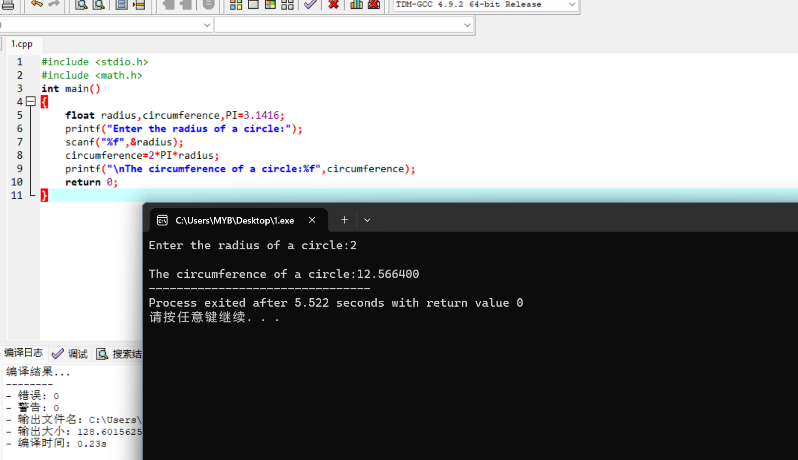

92.1.b

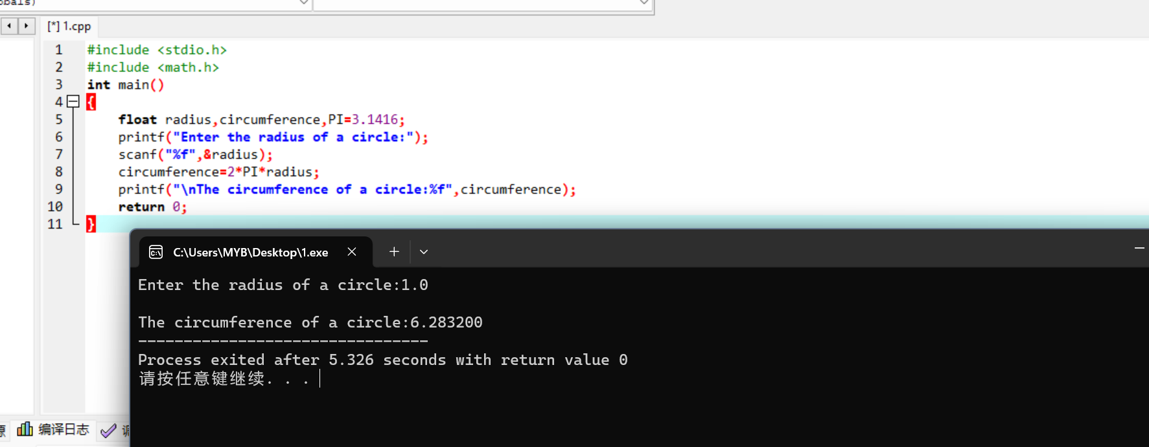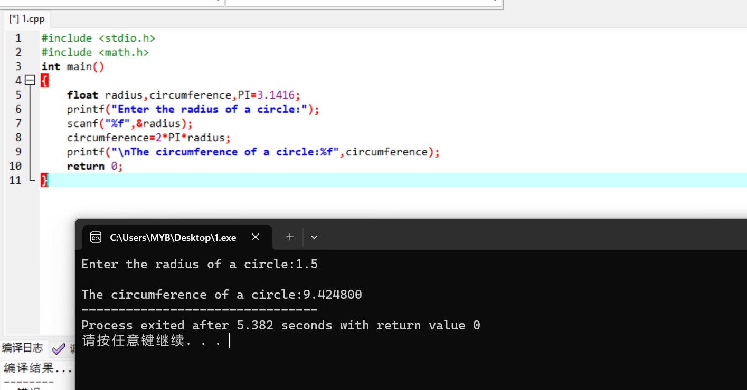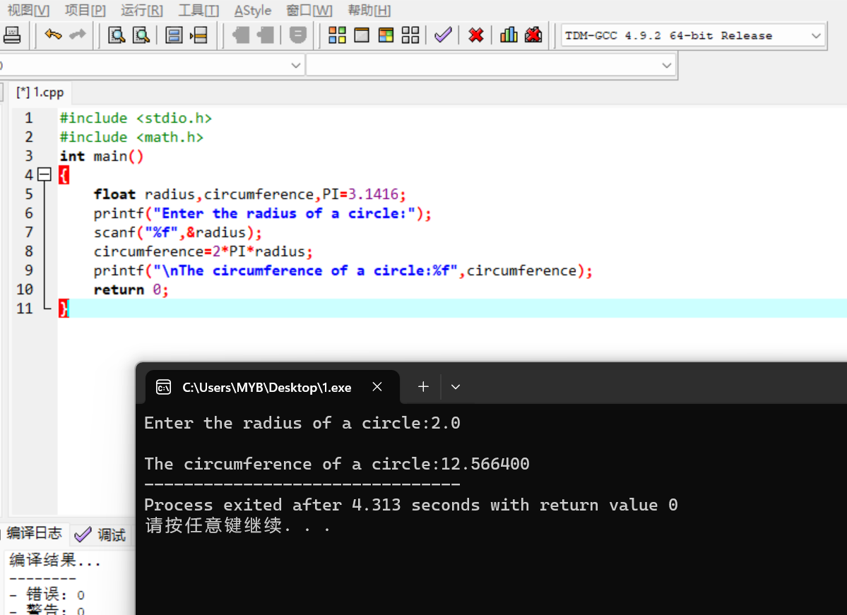

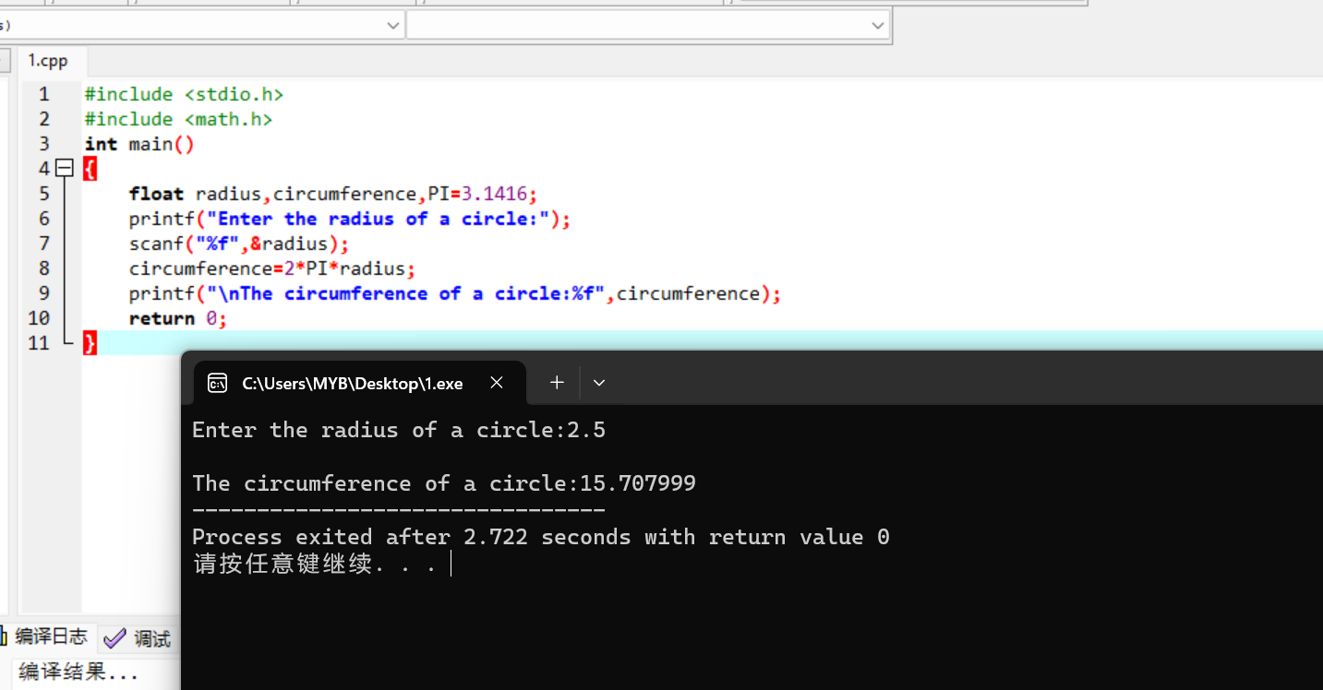

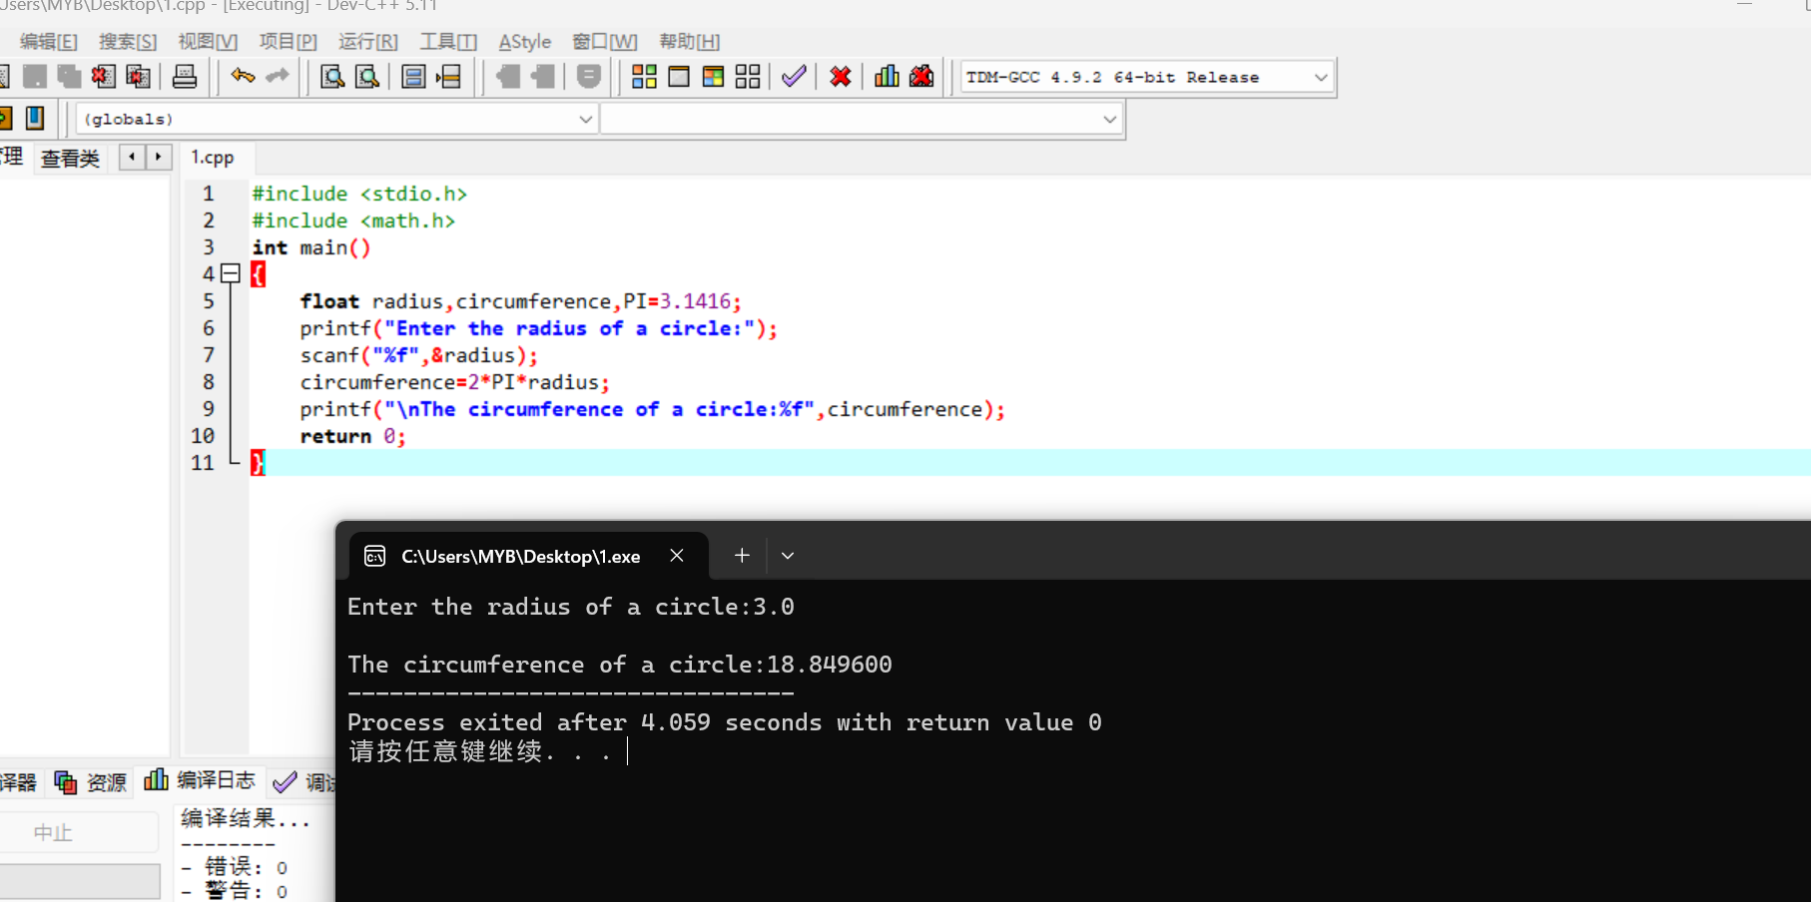

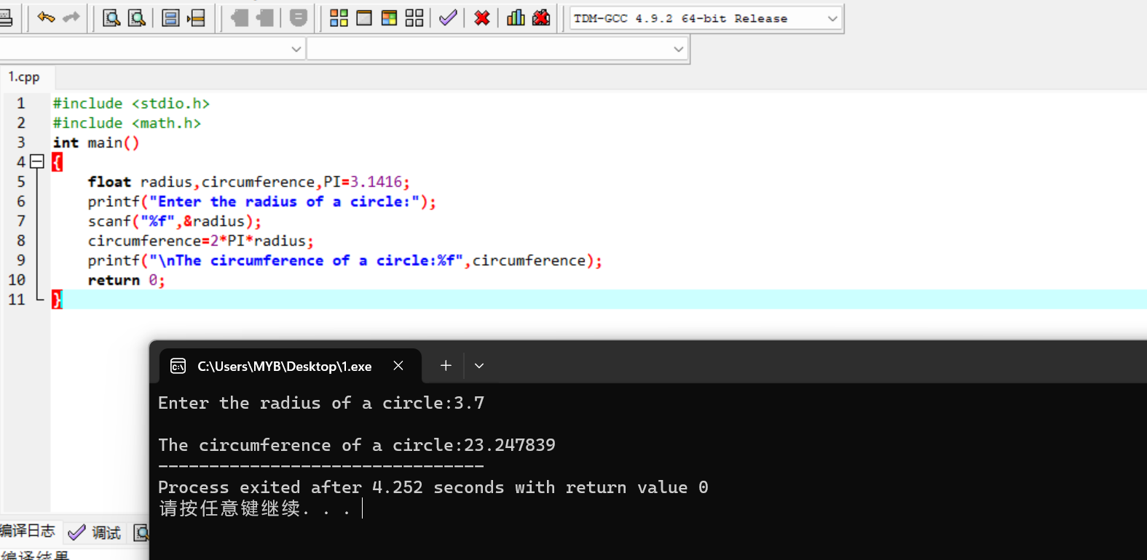

92.2.a

#include <stdio.h>

#include <math.h>

int main()

{

float Celsius,Fahrenheit;

printf("Enter the temperature in degrees Fahrenheit:");

scanf("%f",&Fahrenheit);

Celsius=(5.0/9.0)\*(Fahrenheit-32.0);

printf("Celsius is%f",Celsius);

return 0;

}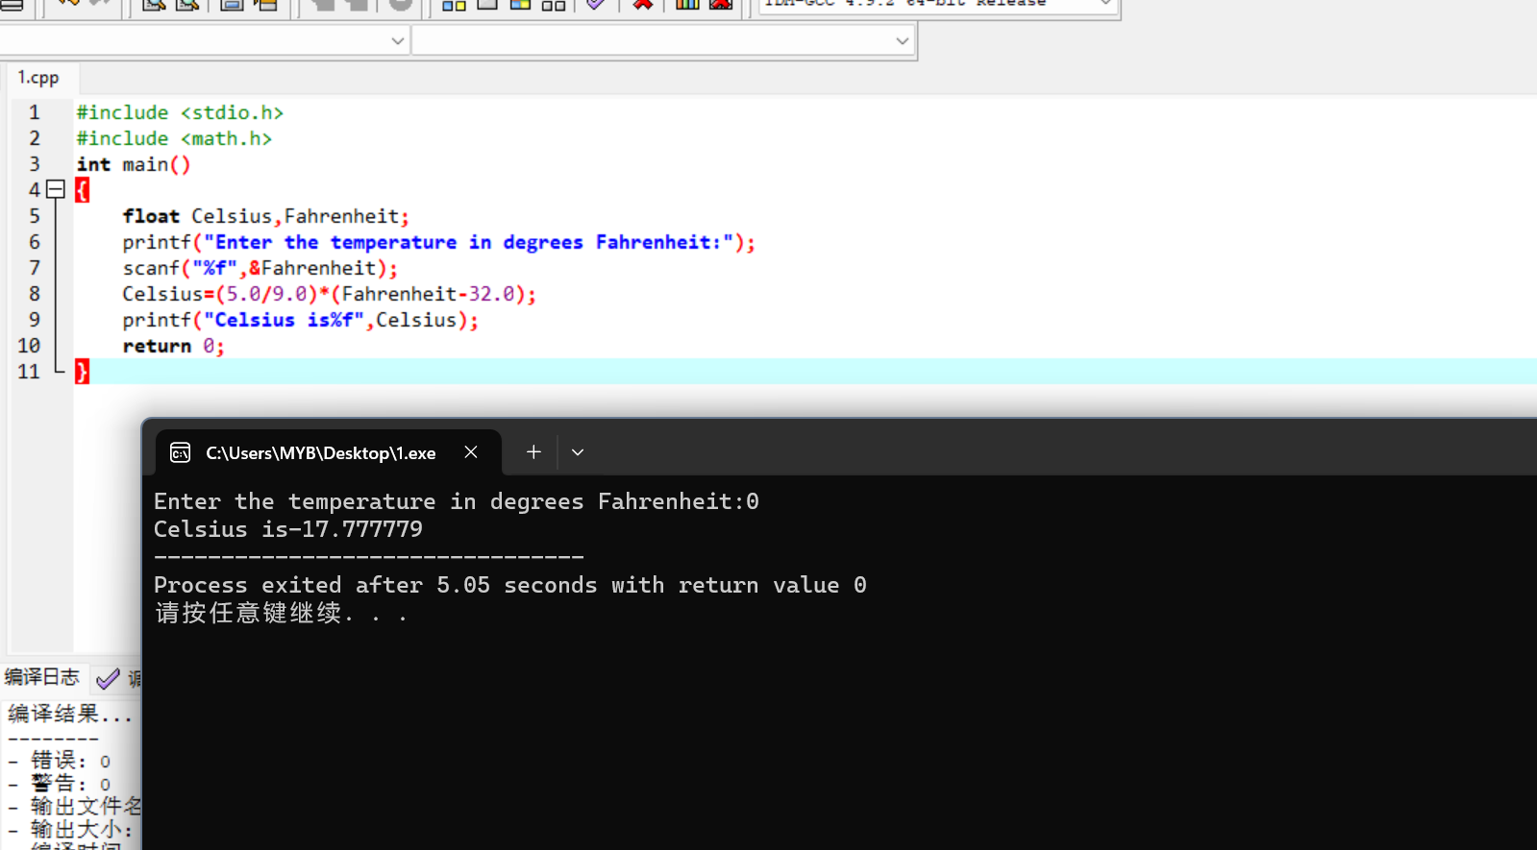

92.2.b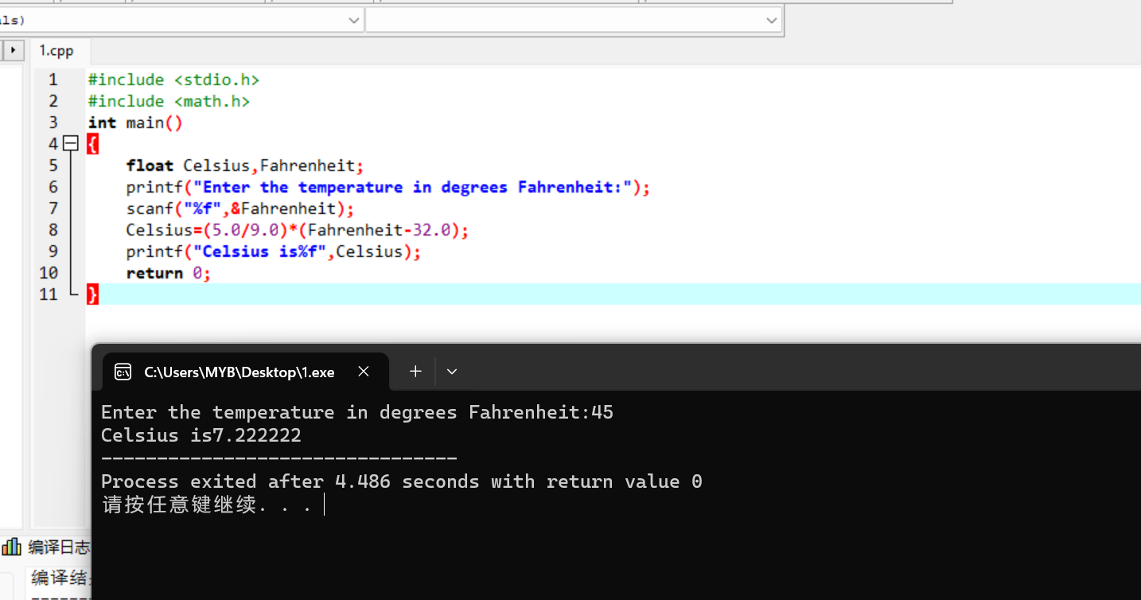

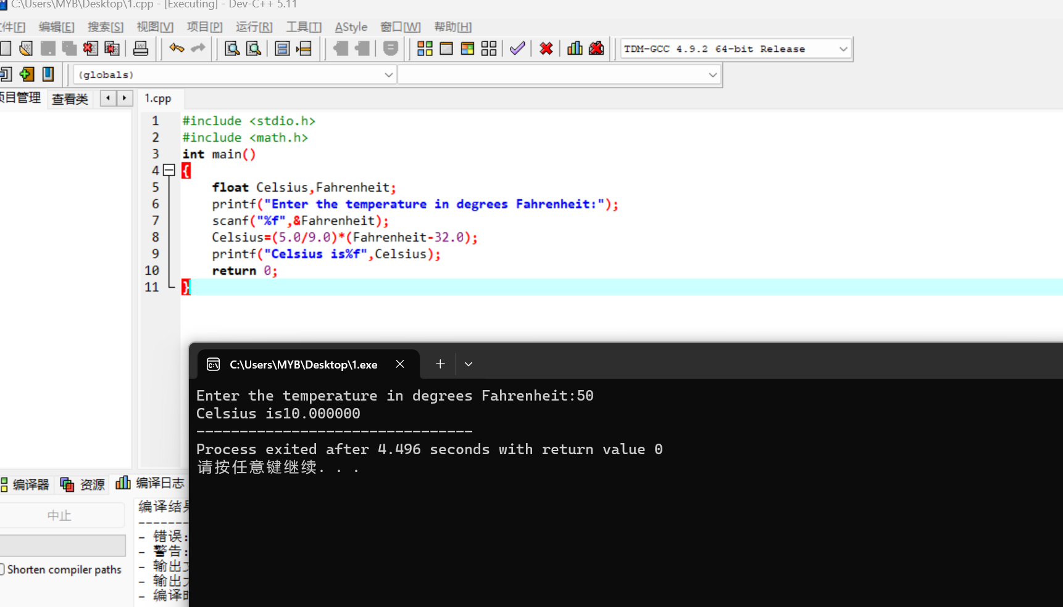

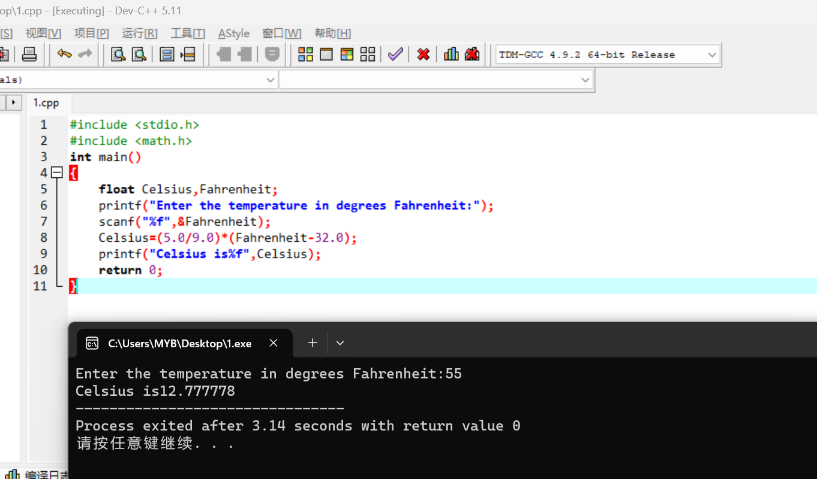

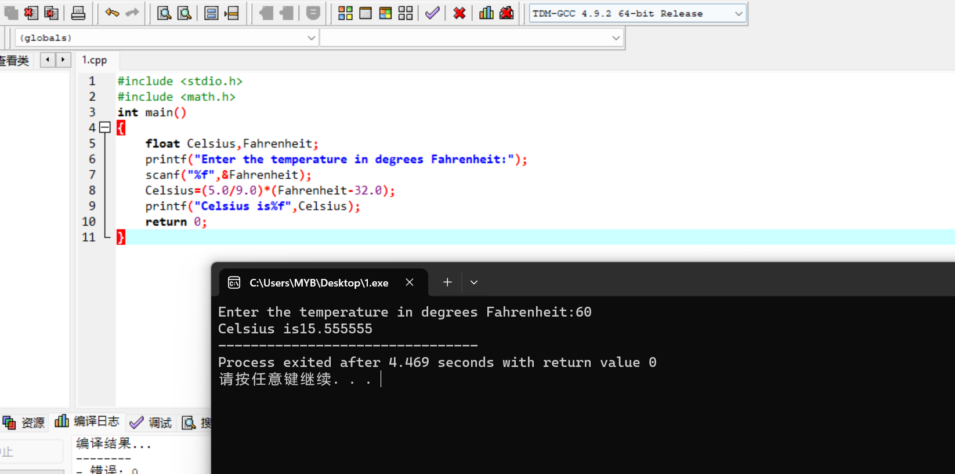

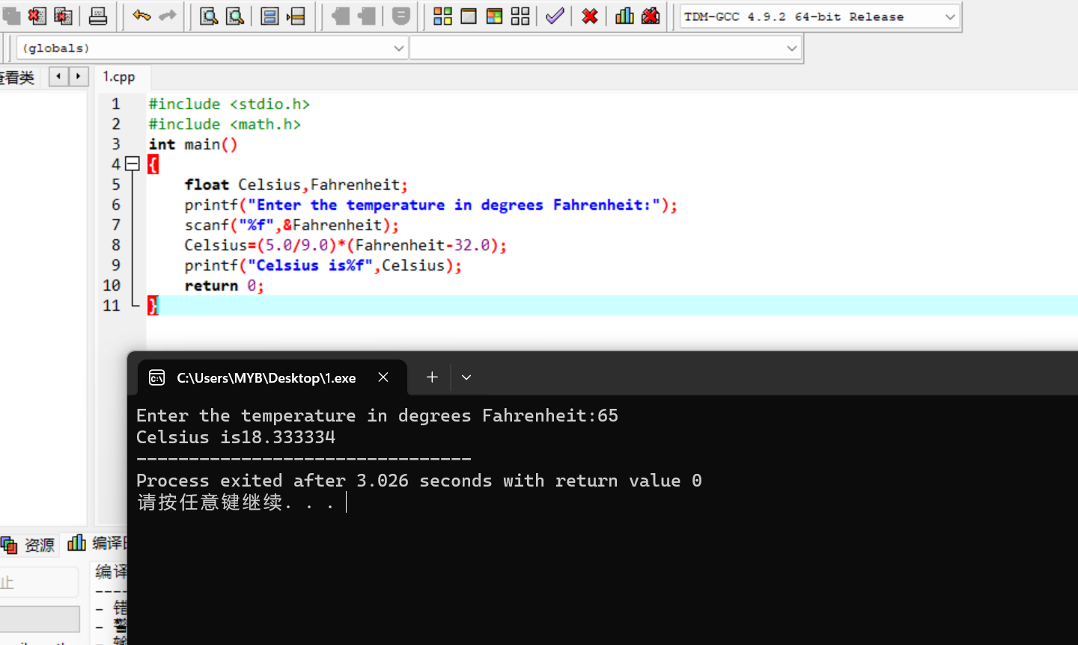

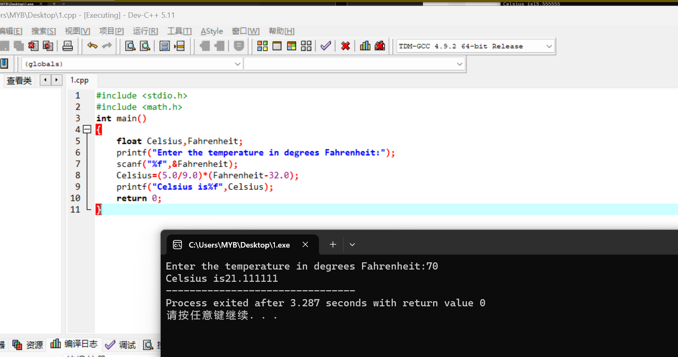

93.6.a

#include <stdio.h>

#include <math.h>

int main()

{

int first,second,third,fourth;

float average;

printf("Enter a number:");

scanf("%d",&first);

printf("\nEnter a second number:");

scanf("%d",&second);

printf("\nEnter a third number:");

scanf("%d",&third);

printf("\nEnter a fourth number:");

scanf("%d",&fourth);

average=(first+second+third+fourth)/4.0;

printf("Average=%f",average);

return 0;

}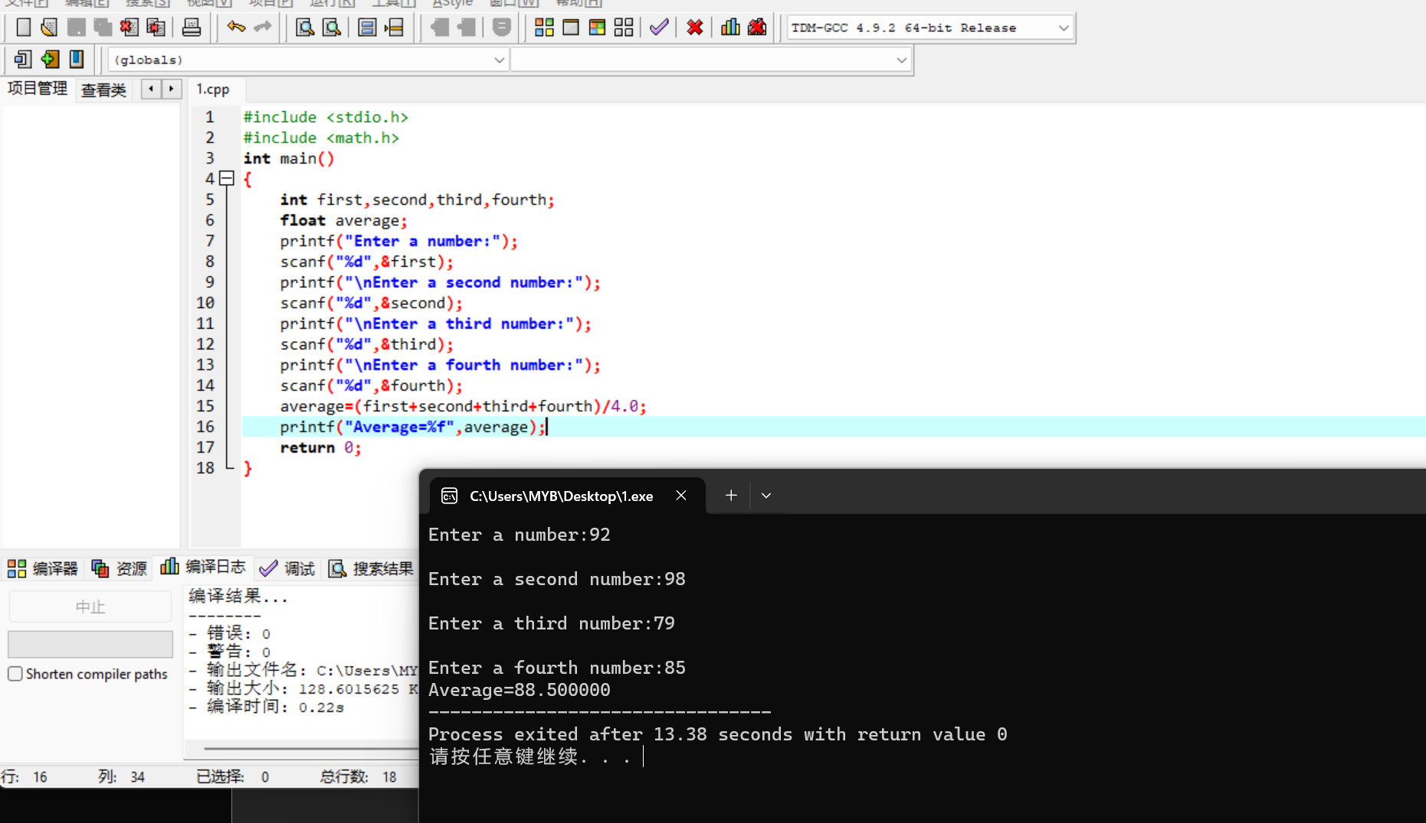

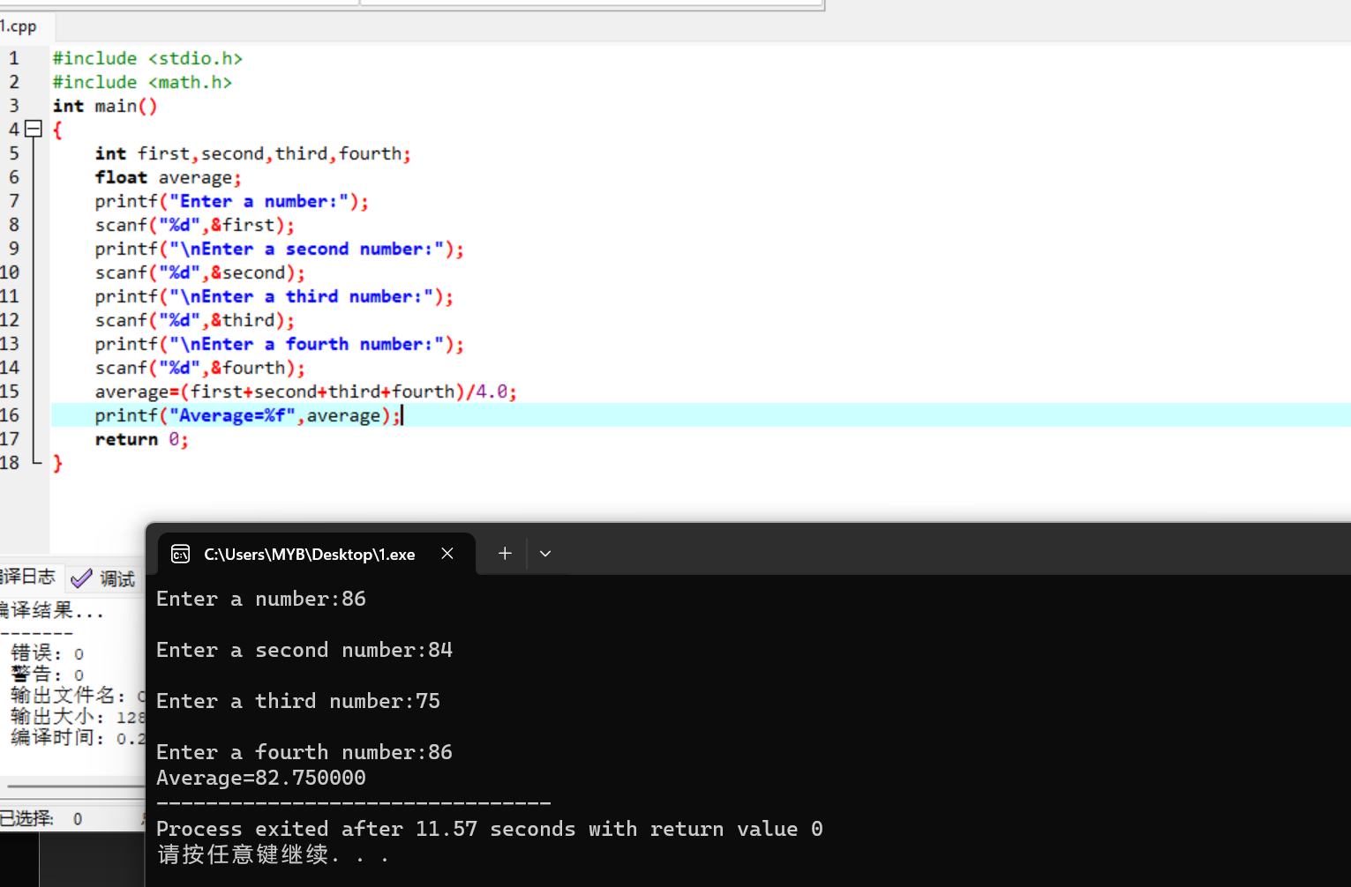

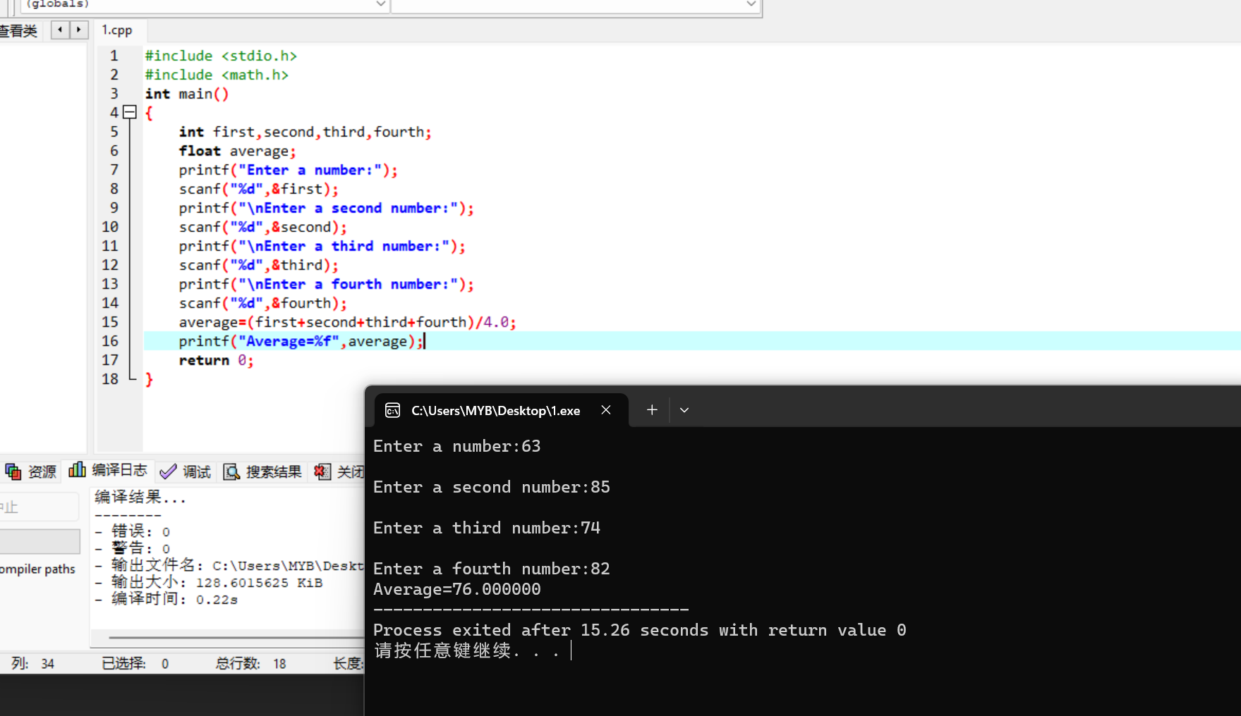

93.6.b

#include <stdio.h>

#include <math.h>

int main()

{

float number,sum;

printf("Enter a number:");

scanf("%f",&number);

sum+=number;

printf("\nEnter a second number:");

scanf("%f",&number);

sum+=number;

printf("\nEnter a third number:");

scanf("%f",&number);

sum+=number;

printf("\nEnter a fourth number:");

scanf("%f",&number);

sum+=number;

printf("Sum=%f",sum);

return 0;

}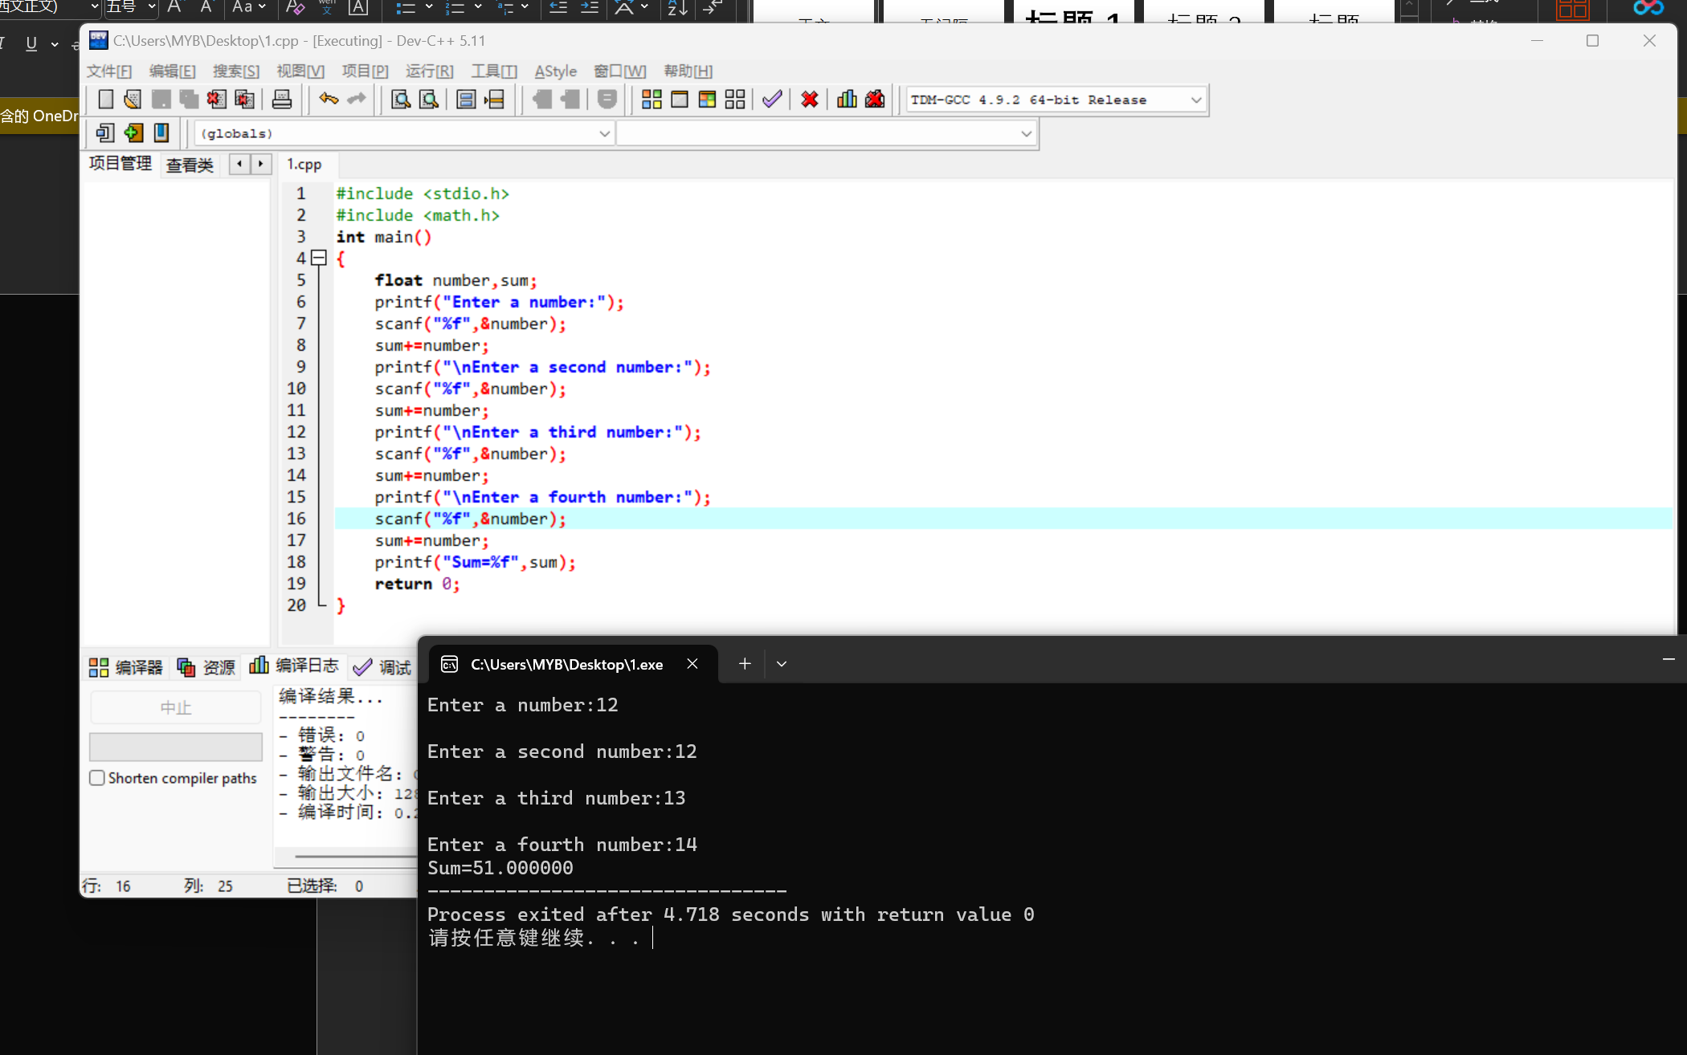

94.7

#include <stdio.h>

int main()

{

int n;

scanf("%d",&n);

printf("number:%d",n);

return 0;

}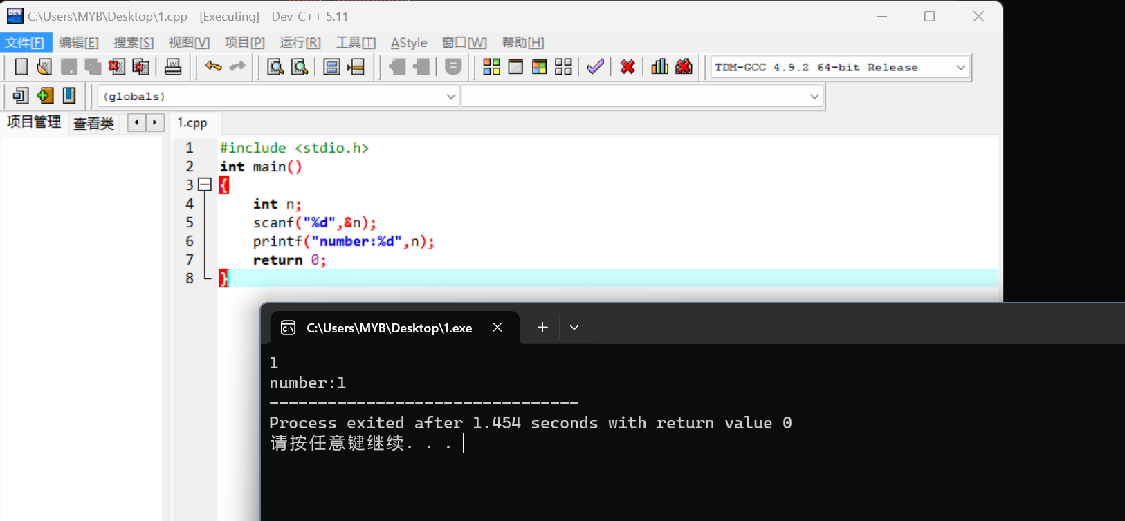

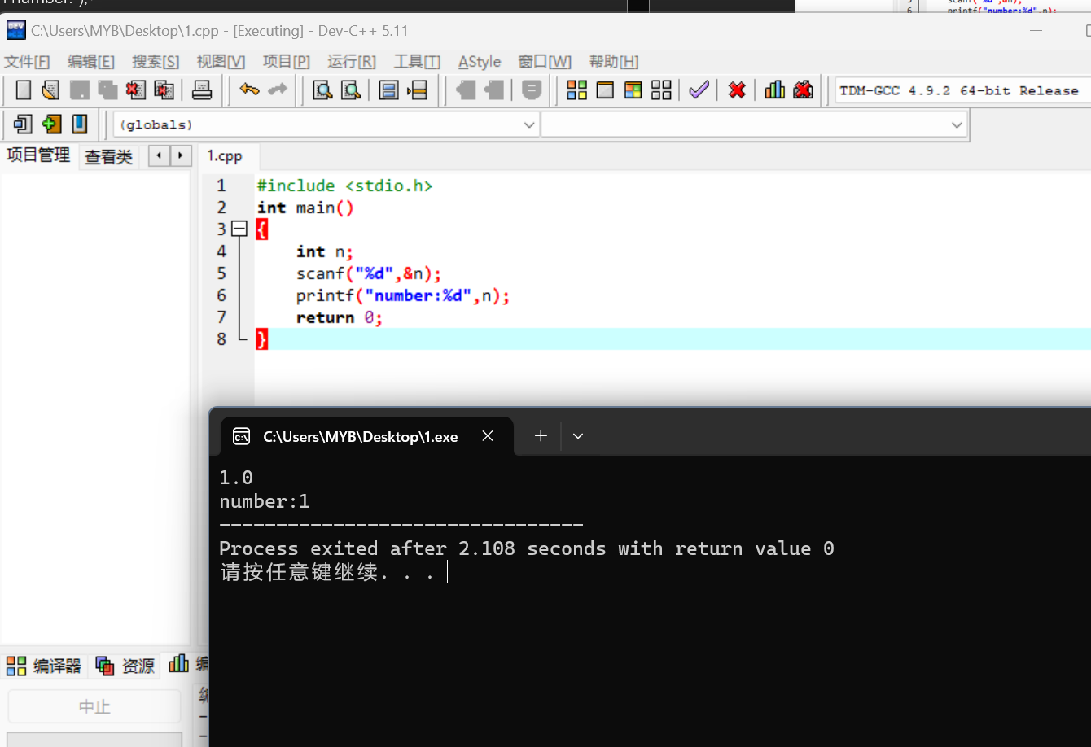

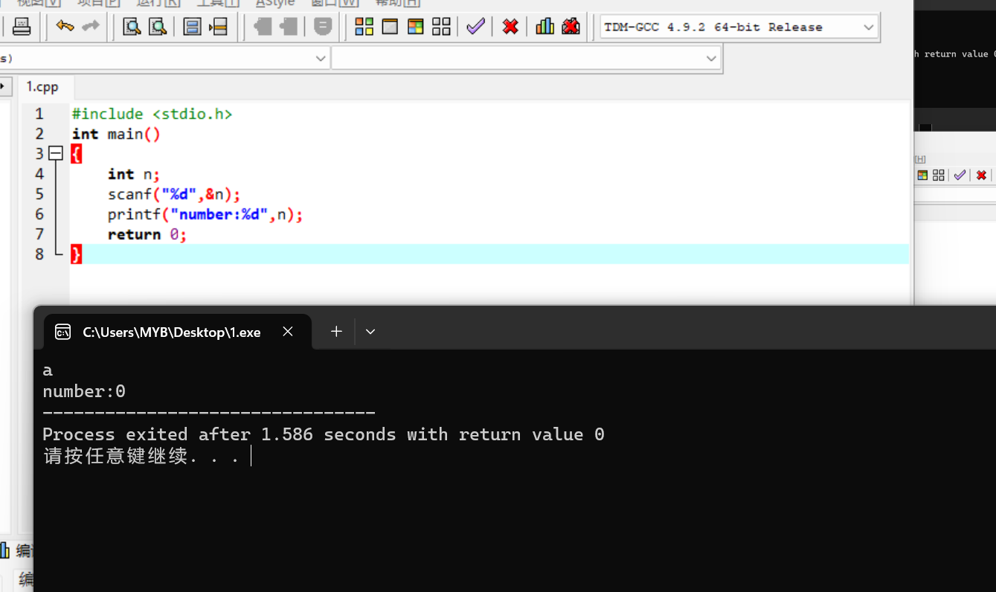

100.3.a

#include <stdio.h>

int main()

{

printf("The sales tax is $%5.2f",.05\*36);

printf("The total bill is $%.2f",37.80);

return 0;

}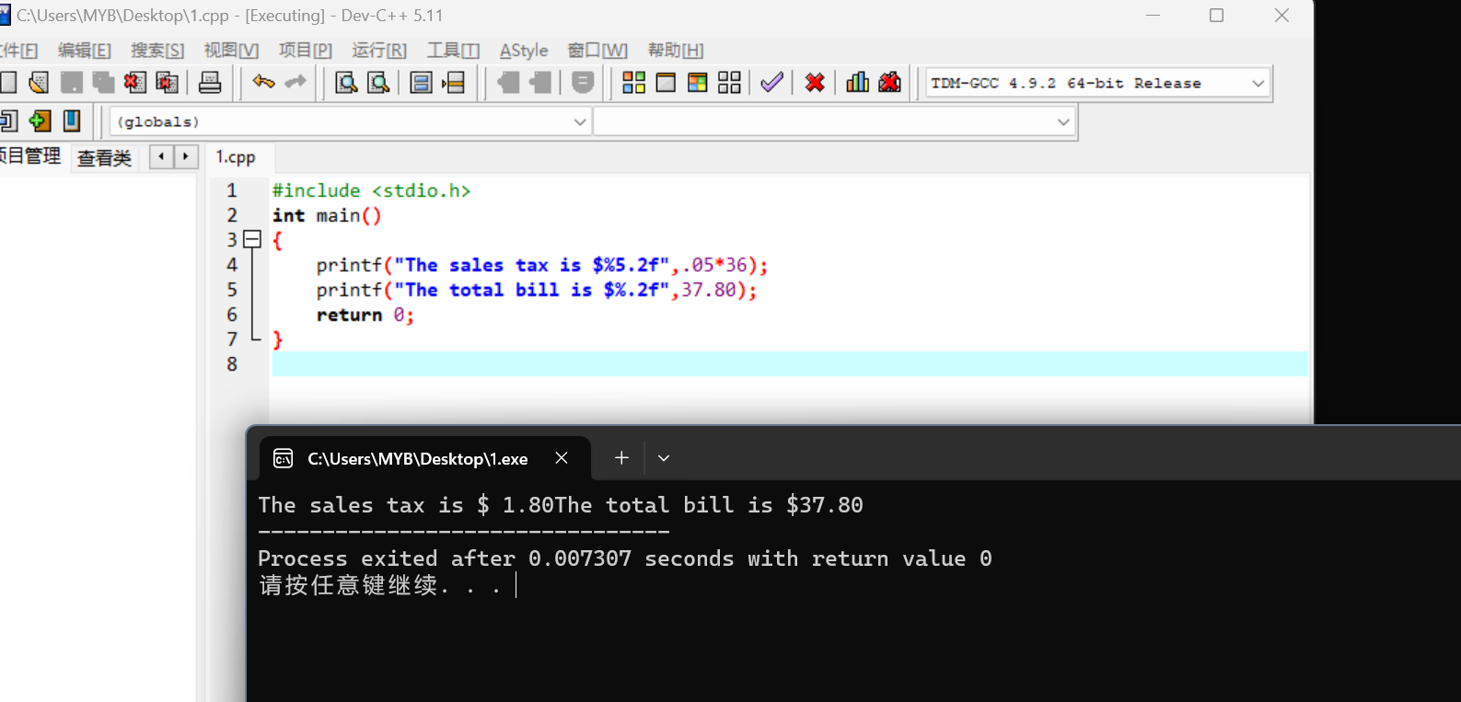

100.4.a

#include <stdio.h>

int main()

{

double a,b,c;

a=1.674;

b=1.322;

printf("\n%4.2f",a);

printf("\n%4.2f",b);

printf("\n----");

c=(double)((int)(a\*100)+(int)(b\*100))/100;

printf("\n%4.2f\n",c);

return 0;

}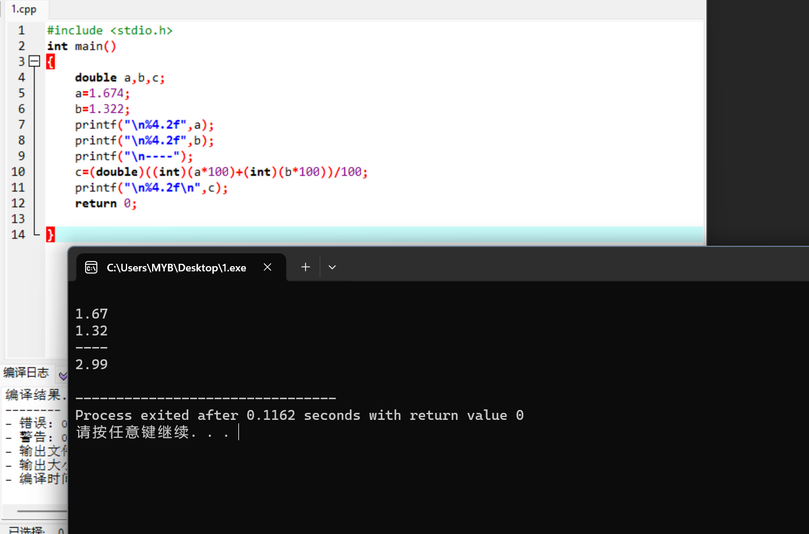

106.2

#include <stdio.h>

int main()

{

float x1,y1,x2,y2,x,y;

printf("Enter the first point:");

scanf("%f,%f",&x1,&y1);

printf("\nEnter the second point:");

scanf("%f,%f",&x2,&y2);

x=(x1+x2)/2;

y=(y1+y2)/2;

printf("\nThe x midpoint coordinate is%f",x);

printf("\nThe y midpoint coordinate is%f",y);

return 0;

}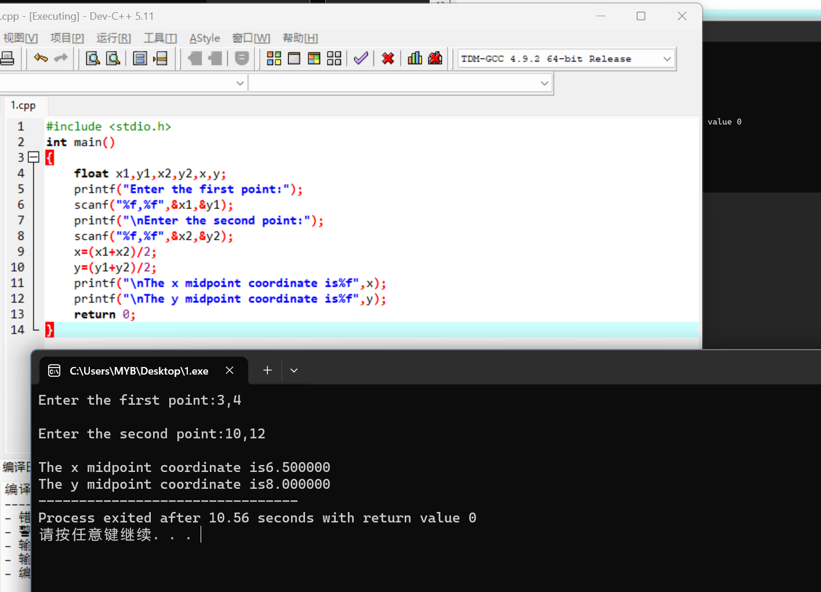

106.2.c

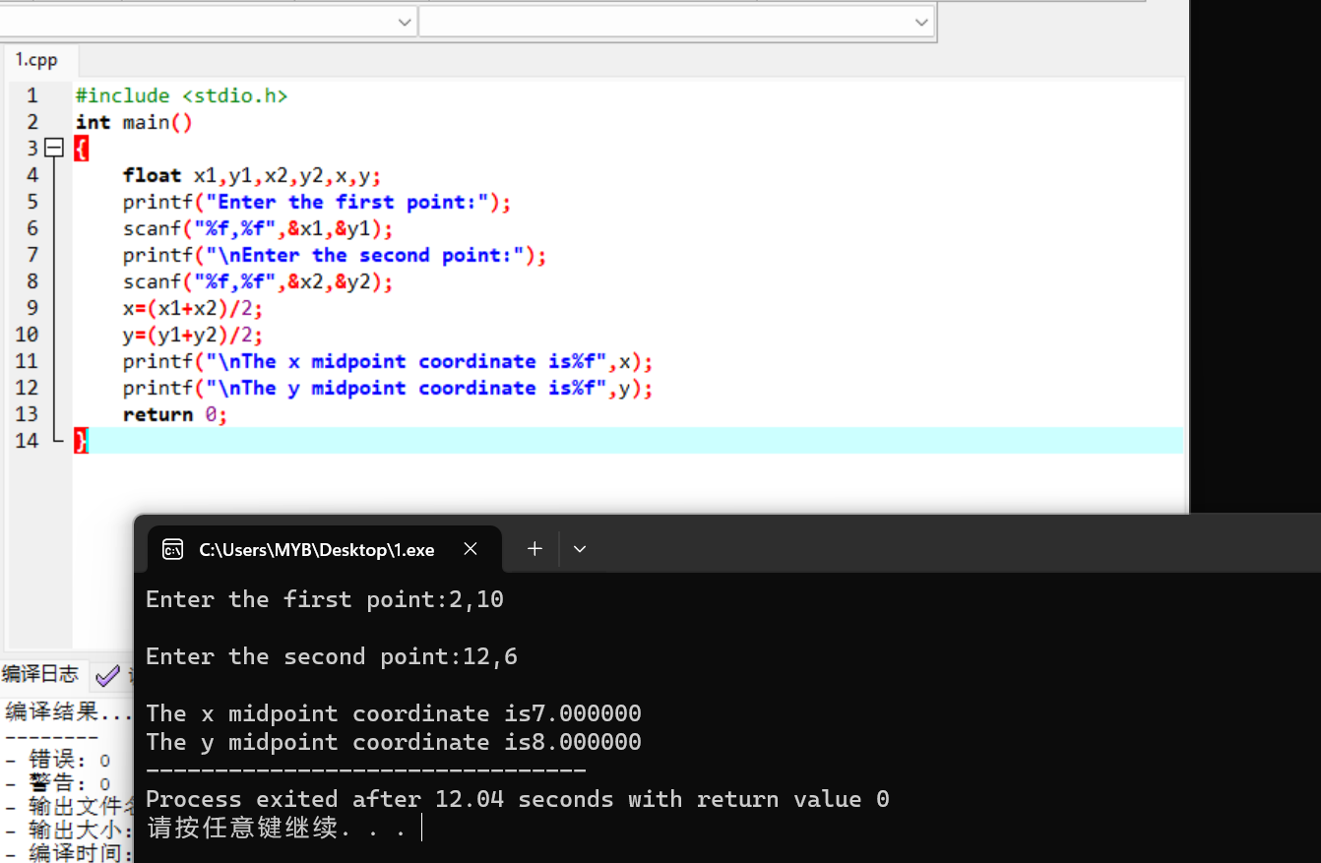

106.4

#include <stdio.h>

int main()

{

float x1,y1,x2,y2,x,y;

printf("Enter the first point:");

scanf("%f,%f",&x1,&y1);

printf("\nEnter the second point:");

scanf("%f,%f",&x2,&y2);

x=(x1+x2)/2;

y=(y1+y2)/2;

printf("The midpoint is(%f,%f)",x,y);

return 0;

}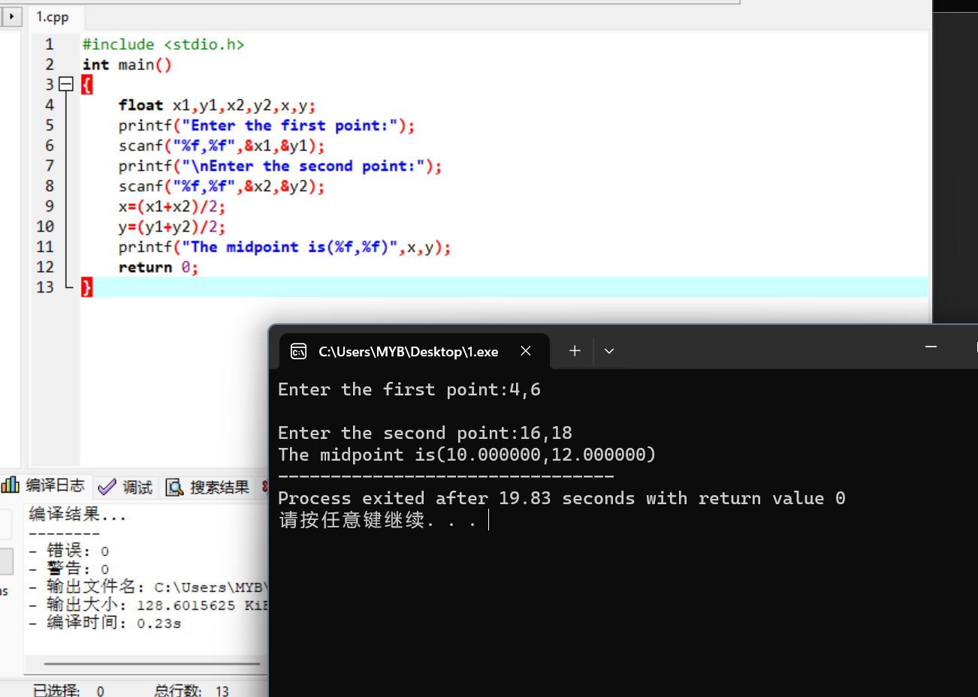

107.6

#include <stdio.h>

#include <math.h>

int main()

{

float A,N,X,R;

printf("\nEnter the amount of the initial deposit.");

scanf("%f",&X);

printf("\nEnter the year you deposit.");

scanf("%f",&N);

printf("\nEnter the interest rate of the bank.");

scanf("%f",&R);

A=X\*pow(1.0+R/100,N);

printf("\nThe amount is %f",A);

return 0;

}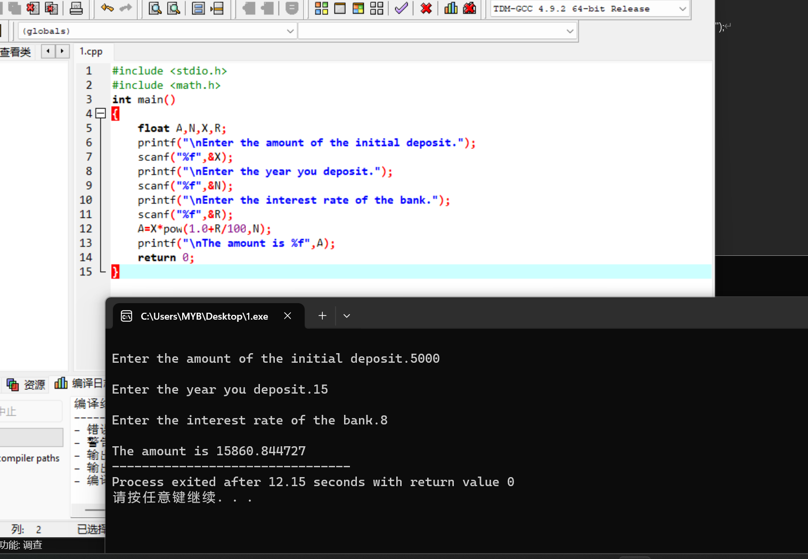

107.7

#include <stdio.h>

#include <math.h>

#define TAXRATE 0.06

int main()

{

float total,discounted,tax,amount,rate,per;

int number;

printf("Enter the number of items,cost-per-item,discount rate:");

scanf("%d,%f,%f",&number,&per,&rate);

total=number\*per;

discounted=total-(total\*(1-rate));

tax=total\*TAXRATE;

amount=discounted+tax;

printf("\nTotal cost is:%f\nDiscounted total cost is:%f\nTax due is:%f\nAmount due is:%f",total,discounted,tax,amount);

return 0;

}